Create database <database-name>;

show databases;

use <database-name>;

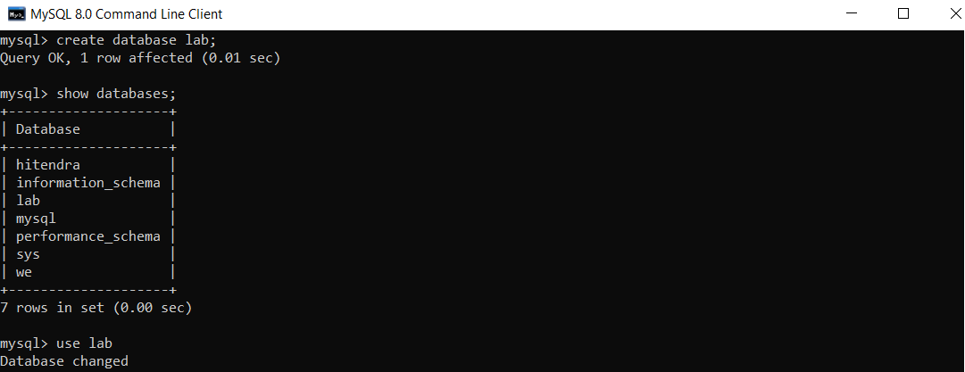

DDL Commands

1. create table <table-name>;

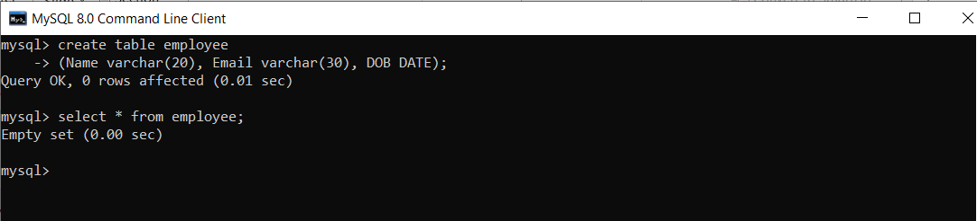

1. Drop table <table-name>;

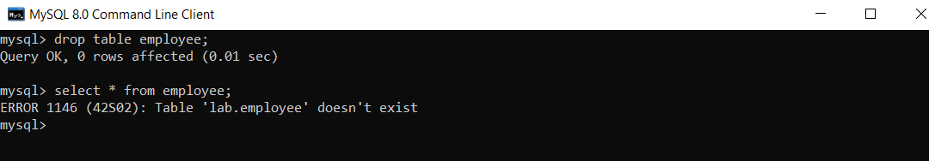

1. Alter table <table-name>
2. add(newcol1 data-type,newcol2 data-type);

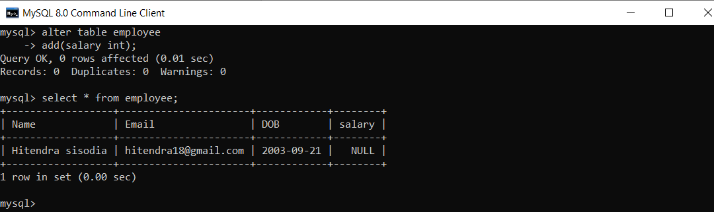

1. modify col1 newdata-type;

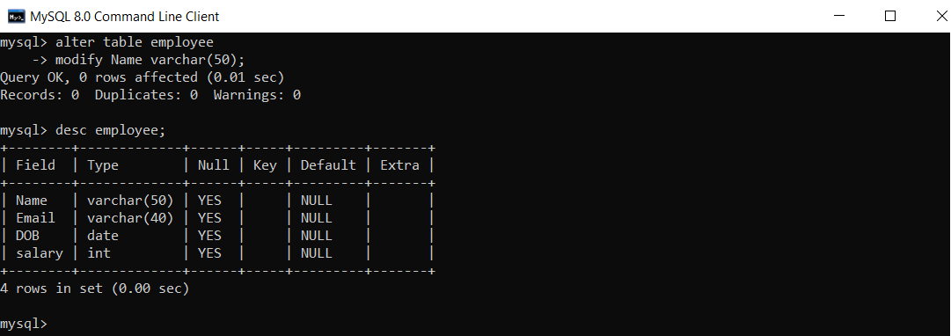

1. truncate table <table-name>;

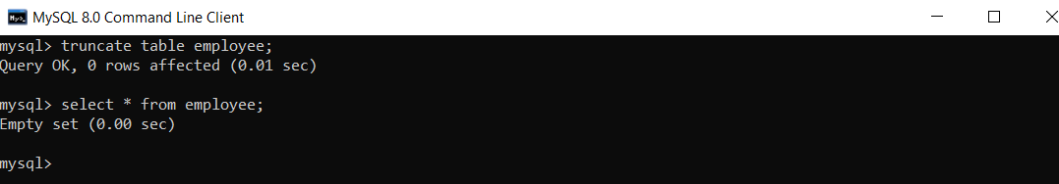

DML Commands

1. insert into <table-name> (col1,col2,col3…..coln) values(val1,val2,val3……valn)

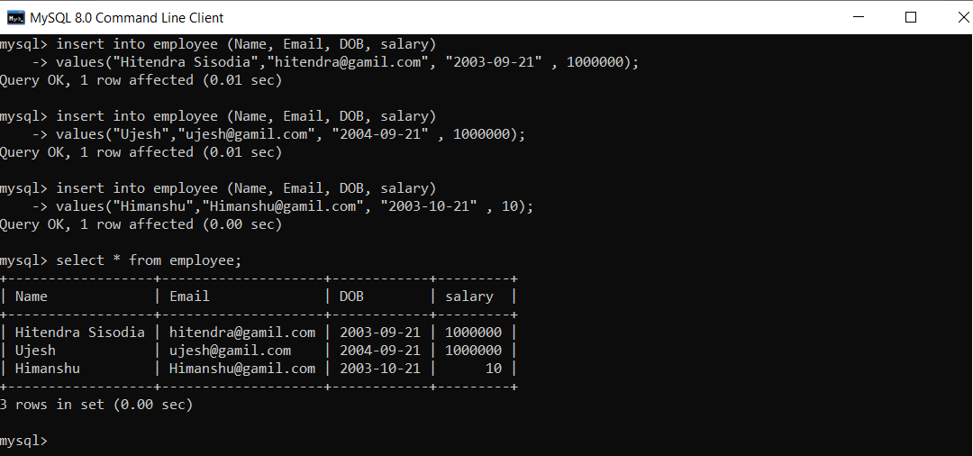

1. update <table-name> set <col1=val1, col2=val2,…..coln=valn> where <condition>

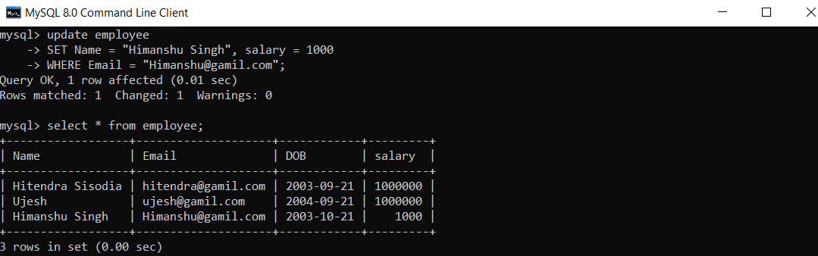

1. delete form <table-name> where <condition>

